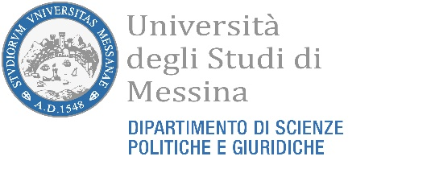
AVVISO INIZIO LEZIONI “LANGUAGE GERMAN”
SI COMUNICA CHE LE LEZIONI DELL’INSEGNAMENTO DI “LANGUAGE GERMAN” DEL CORSO DI LAUREA TRIENNALE “POLITICAL SCIENCES AND INTERNATIONAL RELATIONS” AVRANNO INIZIO GIORNO 20/05/2024 IN AULA N. 3 (EX SALA RIUNIONI) VIA MALPIGHI PRIMO PIANO E SEGUIRANNO CON IL SEGUENTE CALENDARIO:

WE INFORM YOU THAT THE LECTURES OF THE COURSE OF "LANGUAGE GERMAN" OF THE THREE-YEAR DEGREE COURSE "POLITICAL SCIENCES AND INTERNATIONAL RELATIONS" WILL START ON 20/05/2024 IN ROOM N. 3 (FORMER MEETING ROOM) VIA MALPIGHI FIRST FLOOR AND WILL FOLLOW WITH THE FOLLOWING SCHEDULE:

LESSON PLAN GERMAN LANGUAGE | PROF. MARIA CATALANO
20 MAY | 14:30-18:30 | 4 HOURS
23 MAY | 14:30-18:30 | 4 HOURS
24 MAY | 14:30-18:30 | 4 HOURS
27 MAY | 14:30-18:30 | 4 HOURS
28 MAY | 14:30-18:30 | 4 HOURS
29 MAY | 14:30-18:30 | 4 HOURS
30 MAY | 14:30-18:30 | 4 HOURS
31 MAY | 14:30-18:30 | 4 HOURS
04 JUNE | 14:30-18:30 | 4 HOURS
05 JUNE | 14:30-18:30 | 4 HOURS
06 JUNE | 14:30-18:30 | 4 HOURS
07 JUNE | 14:30-18:30 | 4 HOURS

